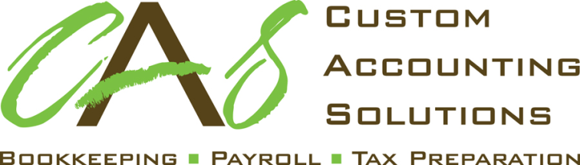

112 East North Street
Albemarle, NC 28001
704-982-3811
Specializing in Bookkeeping, Payroll & Income Tax Preparation

Date: ____________________

Mr. or Mrs. Taxpayer

Subject: Preparation of Your 2023 Tax Returns

Dear Mr. or Mrs. Taxpayer:

Thank you for choosing Custom Accounting Solutions to assist you with your 2023 taxes. This letter confirms the terms of engagement with you and outlines the nature and extent of the services we will provide.
We will prepare your 2023 federal and state income tax returns. We will depend on you to provide the information we need to prepare complete and accurate returns. We may ask you to clarify some items but will not audit or otherwise verify the data you submit.
We will perform accounting services only as needed to prepare tax returns. Our work will not include procedures to find defalcations or other irregularities. Accordingly, our engagement should not be relied upon to disclose errors, fraud, or other illegal acts, though it may be necessary for you to clarify some of the information you submit. We will, of course, inform you of any material errors, fraud, or illegal acts we discover.
The law imposes penalties when taxpayers underestimate their tax liability. Please call us if you have any concerns about such penalties.
Should we encounter instances of unclear tax law, or of potential conflicts in the interpretation of the law, we will outline the reasonable courses of action and the risks and consequences of each. We will ultimately adopt, on your behalf, the alternative you select.
Our fee is based on the time required at standard billing rates plus out-of-pocket expenses. Invoices are due and payable upon presentation. All accounts not paid within thirty (30) days are subject to interest charges to extent permitted by state law.
We will return your original records to you at the end of this engagement. Store these records, along with all supporting documents, in a secure location. We retain copies of your records and our work papers from your engagement for up to seven years, after which these documents will be destroyed.
Our engagement to prepare your 2023 tax returns will conclude with the delivery of the completed returns to you (if paper filing) or your signing, and the subsequent submittal, of your tax return (if e-filing). If you have not selected to e-file your returns with our office, you will be solely responsible to file the returns with the appropriate taxing authorities. You have the final responsibility for the income tax returns and, therefore, you should carefully review them before you sign and file them.
We appreciate your confidence in us. Please call if you have questions.

Sincerely,

Custom Accounting Solutions, Inc.
Heather Little, President

(Both spouses must sign for preparation of joint returns.)
Accepted By:

Taxpayer: ___________________________________________ Spouse: ________________________________________
Date: _______________________________________________

